LO: Apply the series of steps for properly journalizing transactions

Entering transactions in the journal is called **journalizing** and involves the following steps:

1. Select two (or more) accounts impacted by a transaction.
2. Determine how much, in dollars, each account is affected. Amounts either are given or must be calculated based on information provided.
3. Based on the rules of debit and credit, decide which account(s) is debited and which is credited.
4. Enter the date on the first line of the transaction only.
5. Enter the account that will be **debited** on the **first line** of the transaction. Enter its amount in the **Debit** column on the same line.
6. Enter the account that will be **credited** on the **second line** of the transaction. Indent the credit account name,  Enter its amount in the **Credit** column on the same line.

The following journal excerpt for Core Fitness shows how sample transactions are entered.

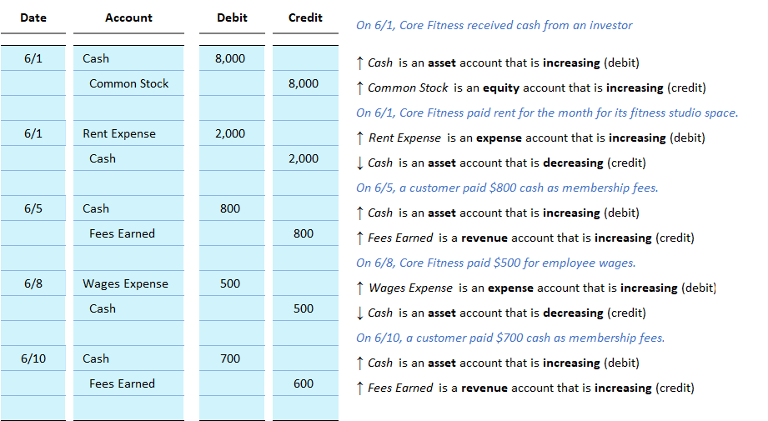

## Interactive Exercise 4 – Journal Entries

***Instruction*:** Journalize the following transactions.

On 6/1, an individual invested $10,000 in the a corporation.  
On 6/1, the company paid rent of $1,500 for the month for its office space.  
On 6/5, a customer paid $1,700 cash for services the company provided.  
On 6/8, the company paid $1,100 for employee wages.  
On 6/10, a customer paid $2,600 cash for services the company provided.

|  |  |  |  |  |  |  |
| --- | --- | --- | --- | --- | --- | --- |
|  | | | | |  |  |
| **Date** | **Account** |  | **Debit** | **Credit** |  |
|  |  |  |  |  |  |
| 6/1 |  |  |  |  |  |
|  |  |  |  |  |  |
|  |  |  |  |  |  |
| 6/1 |  |  |  |  |  |  |
|  |  |  |  |  |  |  |
|  |  |  |  |  |  |  |
| 6/5 |  |  |  |  |  |  |
|  |  |  |  |  |  |  |
|  |  |  |  |  |  |  |
| 6/8 |  |  |  |  |  |  |
|  |  |  |  |  |  |  |
|  |  |  |  |  |  |  |
| 6/10 |  |  |  |  |  |  |
|  |  |  |  |  |  |  |
|  |  |  |  |  |  |  |

*[Hint:* Assets and expenses increase by debiting. Liabilities, stockholders’ equity, and expense accounts increase by crediting.]

*[ANSWER KEY]*

|  |  |  |  |  |  |  |
| --- | --- | --- | --- | --- | --- | --- |
|  | | | | |  |  |
| **Date** | **Account** |  | **Debit** | **Credit** |  |
|  |  |  |  |  |  |
| 6/1 | Cash |  | 10,000 |  |  |
|  | Common Stock |  |  | 10,000 |  |
|  |  |  |  |  |  |
| 6/1 | Rent Expense |  | 1,500 |  |  |  |
|  | Cash |  |  | 1,500 |  |  |
|  |  |  |  |  |  |  |
| 6/5 | Cash |  | 1,700 |  |  |  |
|  | Fees Earned |  |  | 1,700 |  |  |
|  |  |  |  |  |  |  |
| 6/8 | Wages Expense |  | 1,100 |  |  |  |
|  | Cash |  |  | 1,100 |  |  |
|  |  |  |  |  |  |  |
| 6/10 | Cash |  | 2,600 |  |  |  |
|  | Fees Earned |  |  | 2,600 |  |  |
|  |  |  |  |  |  |  |

## Test Your Understanding

Which of the following is a correct journal entry?

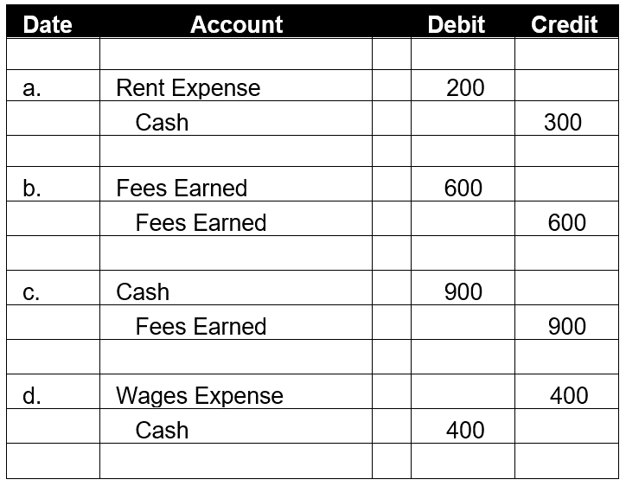

*[MCQ. Correct Answer is c.]*